
Submitted To:
Mrs. Syeda Ramish Fatima
Submitted By:
Muhammad Ashar Khan (CS-24035)
Usman Rasheed Siddiqui (CS-24038)
Submitted On:
21th February 2025
Object Oriented Programming
(CS-116)
Graded Assignment 1: Class Diagrams

COMPUTER AND INFORMATION SYSTEM ENGINEERING
NED UNIVERSITY OF ENGINEERING AND TECHNOLOGY

Colors for Association Types in Class Diagram:
- #FCEF61 (For Main Class)
- ⁠#A3E0FF (For Aggregation)
- ⁠#A3FFA3 (For Composition)
- ⁠#C6C6C6 (For Generalization)
- ⁠#FF8282 (For Association)
- #79FFE8 (For Multiple Associations on a single class)

Class Diagram Representation of Problem Scenarios:

Question 1:
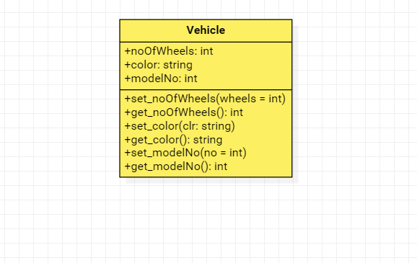

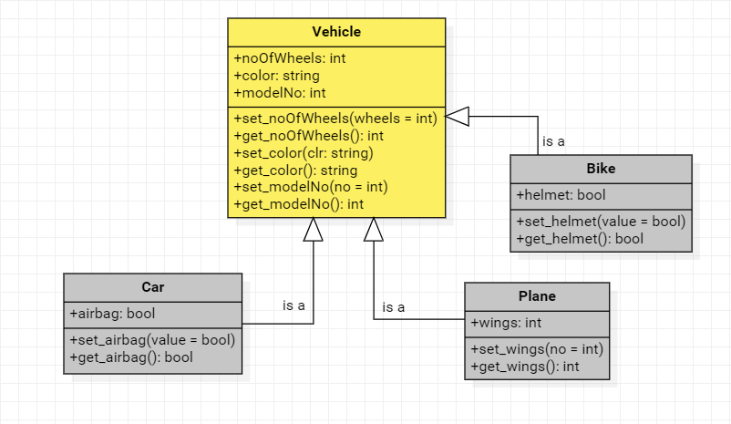
Question 2:

Question 3:
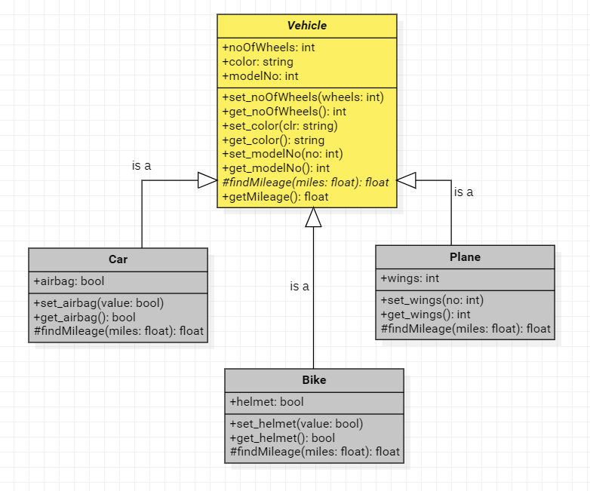

Question 4:
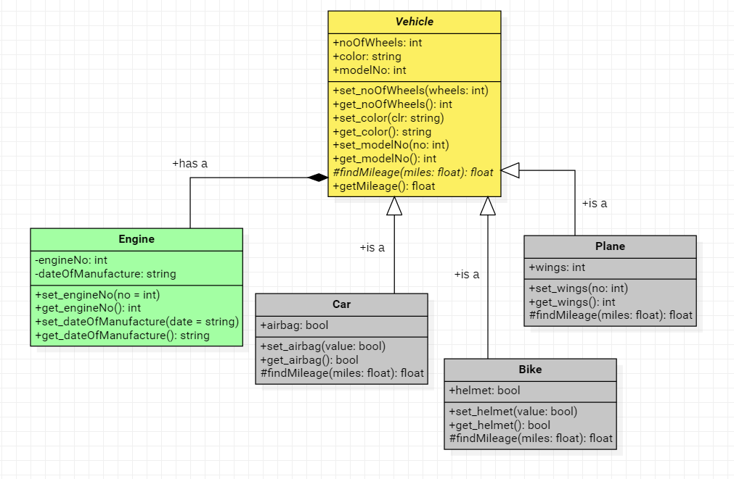

Question 5:
Part (a):
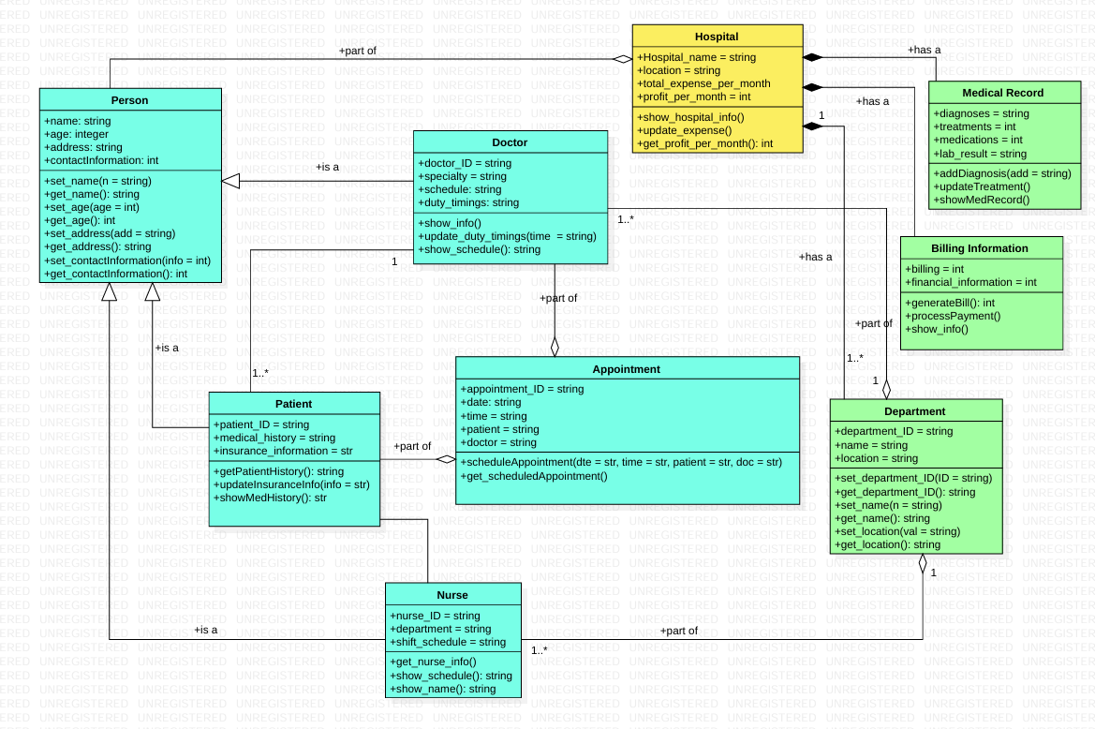

Part (b):
